Connect
Report
Success
Record
Recording Visits
Visit data provides the essential data to review your services. It is the primary function of every tracking system, from paper and pencil to spreadsheets to your Trac System. The visit data assists with everything from evaluating student success to acquiring funds for your program. While there are many tools available to record visits, the Kiosks and the Log Listings provide flexible, real-time login services to your students. Participants in this session will review the basics of the login features, as well as discover some more advanced options to customize your login processes. Come and see why the Kiosks and the Log Listing are the preferred methods for recording your visits.

Log Student Window
- Appears at the Top of Every page in the Trac System and allows Students to be logged in either using their Name or ID number. This can also be set up to work with a card reader or barcode scanner allowing students to sign in using their student ID card
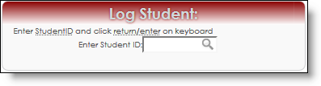
Quick Visits
- Allows you the ability to quickly create visits after the visit has taken place or if your computer/internet is inaccessible
  - To activate the Quick Visit link on your Main Menu, go to the Trac Navigation -> TracMan Icon -> My Prefs -> Check the Quick Visits box -> Click Save.
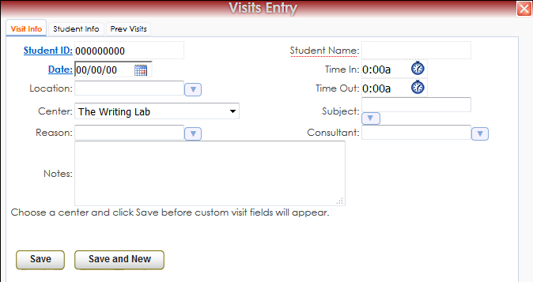

Batch Entry/S.I. Batch Entry
- Allows you to record visits for a Group, Workshop, or SI Session. 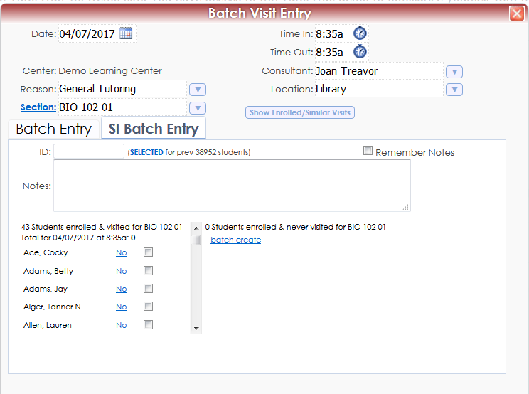
Dynamic Kiosks
- Allows Users to Pre-select the fields for the Student when they log in to a Kiosk.
  - When setting up the Kiosk, you will check the Dynamic Kiosk Box and then select the options below that you would like to pre-select once signed in to the kiosk.
