Connect
Report
Success
Record
Student Access and View in Trac
The Trac System provides students the ability to manage their own appointment schedules and review their activity history utilizing student services. Student involvement allows students to take ownership of their success and is easily accomplished with the Trac System. This session will review how students may be provided access and instruction to specific areas of the Trac System as well as look at the Trac System from the student perspective. Participants will learn how to navigate and set the various options for student access and view the Trac System from a student point of view.
Advanced Prefs
- Trac Navigation -> TracMan Icon -> Utilities and Prefs -> System Prefs tab -> Student Access
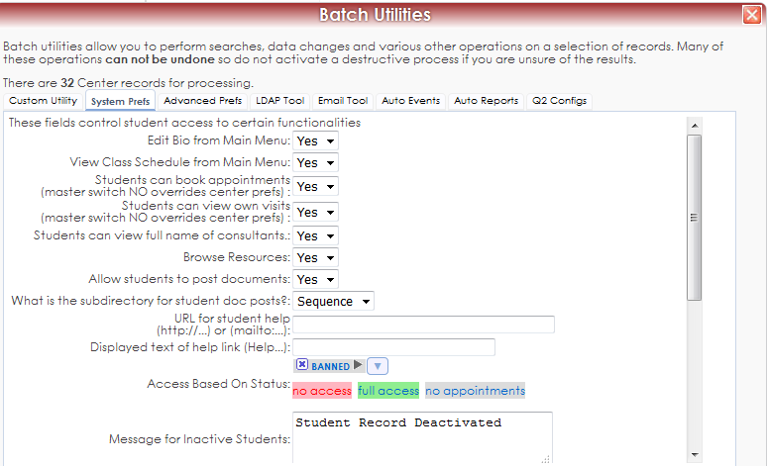
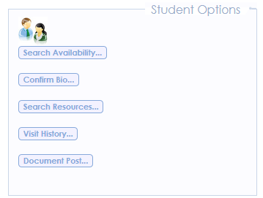
Student Links on Login
- Schedule Appointments
- Confirm Bio
- Search Resources
- View Visits
- Post Documents
- View Messages About Appointments
- Cancel Appointments

Opt in to Receive Text Alerts and Edit SMS Settings
- Students can opt-in to receive text messages by generating an activation code and then sending a SMS message from their mobile device. Once TextAlerts has been activated they can customize the type of texts they would like to receive and how many minutes prior to an appointment do they want a text reminder.
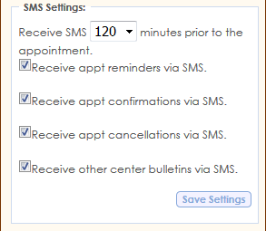
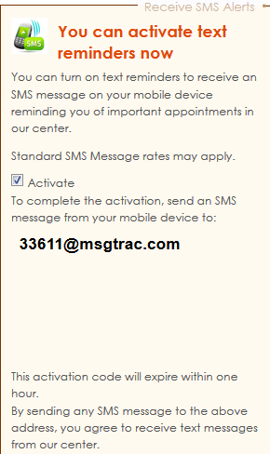
Class Schedule Tab on Student Main Menu
Please note: In order to have the students class schedule appear in the system we must be importing courses, course start and times and start and end dates. You may need to work with your IT department and Redrock Software to make sure that the correct information is being imported into your Trac System.
- To activate the Class Schedule tab on the Student Main Menu, (must be logged in as a Sys Admin) you will need to go to the Trac Navigation -> TracMan Icon -> Utilities and Prefs -> Advanced Prefs tab -> Search for “StudClassSched” -> Set to “YES” -> Save.
