Connect
Report
Success
Record

Automatic Reports
Reports can be set up to automatically be emailed to recipients. There are three steps to configuring automatic reports. First, the automated report events need to be created. Second, a user needs to save the desired auto report as a favorite report. Finally, the user indicates which automated report event schedule the report will run under.

Setting the Automated Report Events.
Prior to allowing users to set reports to run automatically, the system administrator will need to perform some configuration:
1. Log in as a System Administrator.
2. Click on the 'TracMan' icon and choose the 'Utilities and Prefs' option, and access the 'Auto Reports' tab.
3. The 'Auto Reports' tab allows you to create the automated events that control when reports are initiated. Click on the 'New' button to create a new automated report event.
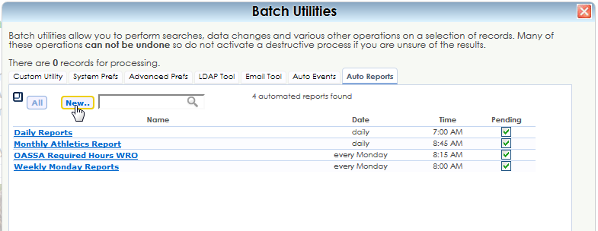
4. Enter the name of the automated report event you would like to create. Then edit the frequency and time of the event. Save the new event when you're done. NOTE: Double check that the time you choose is not the same as any other Auto Reports or Auto Events. This is extremely important because if there are two "Auto Reports/Events" that attempt to run at the same time, one or both will not execute.

Saving Favorite Reports
Now that the automated report events have been created, the next step is for users to save desired auto reports as favorite reports.
1. Open the report chooser, and navigate to the report you would like to automate.
2. Set the parameters of the report that you would like to run. You'll need to use one of the preset date options for computing the dates of the report.
3. Once you've adjusted all the fields and dates be sure to check "Auto Recompute Dates" next to the date field and 'Save new favorite' at the bottom of the window.
4. You will also want to enter the email addresses for which this report should be sent.
5. Then click 'generate'. This will save the report to your favorites category.

Automating the Reports
Now that the reports are located in the 'Favorites' Category, you can assign them to one of the automated report events.
1. Go back to your 'Favorites' category. You will find the newly saved favorite report there.
2. Click on the favorite report that you want to auto run. Under the list of reports there will be two blue buttons, 'Remove' and 'Auto Run...' Click on 'Auto Run'.
3. From the drop down menu, choose the auto report title that you want to assign this report to. Check the box to 'Save over existing'. You'll also need to change the delivery format to 'Email', and enter the email addresses to receive the email. If there are multiple email addresses, separate them with a semicolon (;).
4. Click 'Generate' to save. This will send the report to all of the email addresses listed at this time; however, this is how the report settings are saved.
To double check the automated report, you can go back to the 'Utilities and Prefs' option under the 'Auto Reports' tab, and click on the auto report event you assigned the report to. You will see the linked report name to the right.

