Connect
Report
Success
Record

Prefs.ini

Server settings necessary for your Trac system are stored in the prefs.ini file. This example shows a basic setup for a TutorTrac installation using secured https redirect.

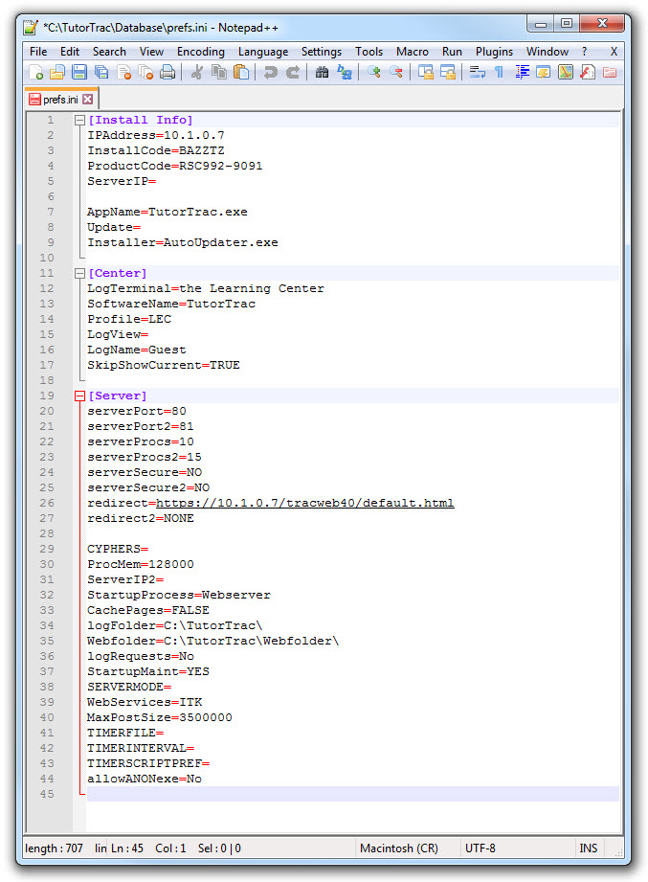
Common items to verify:
- Use only static IP addresses
- Server ports (defaults are shown, but others may be used)
- Redirect settings point to secure IP

