**Automated Study Hall Reports**

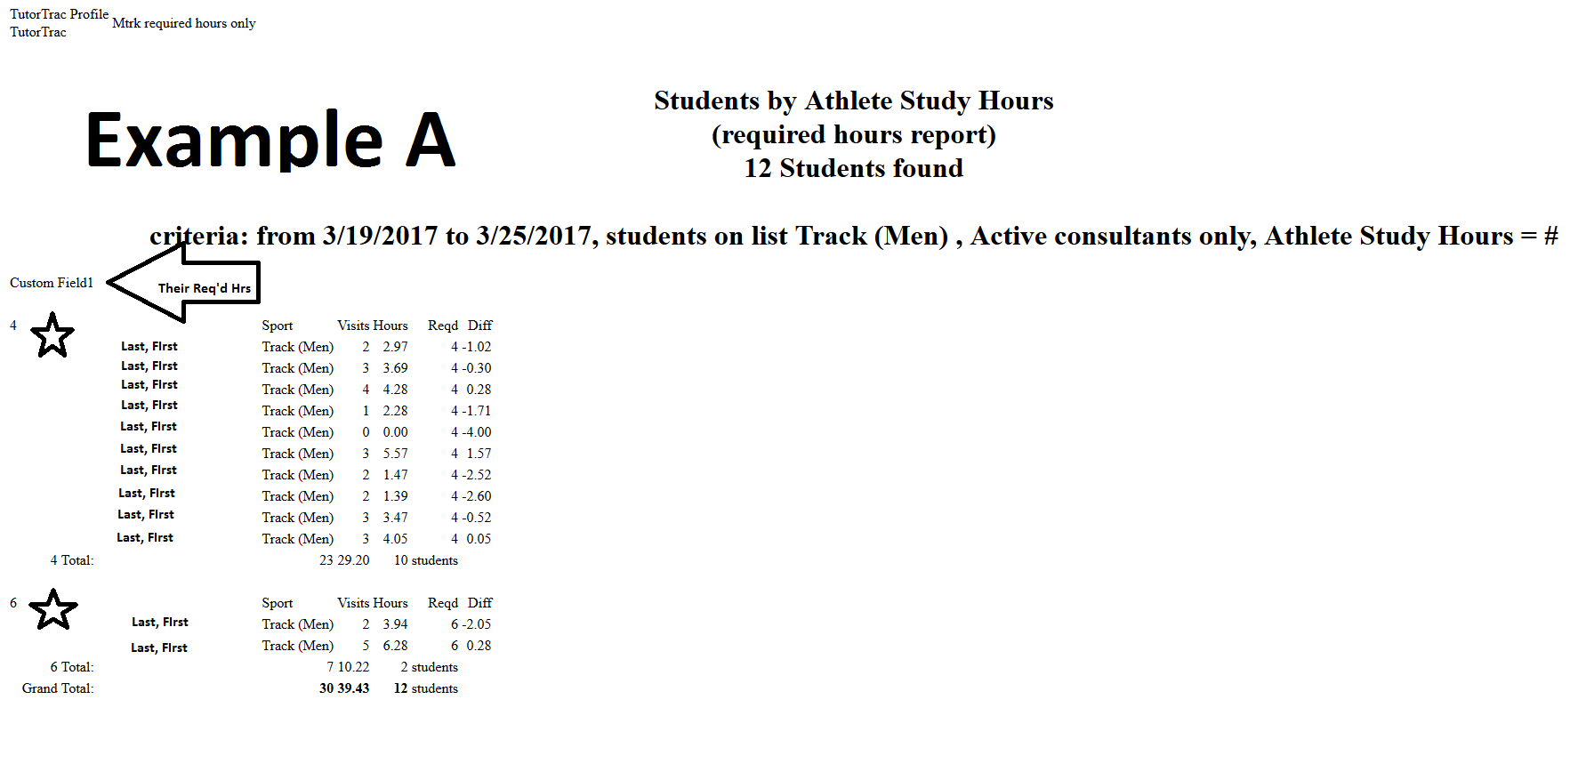

**Automated Tutorial Reports**

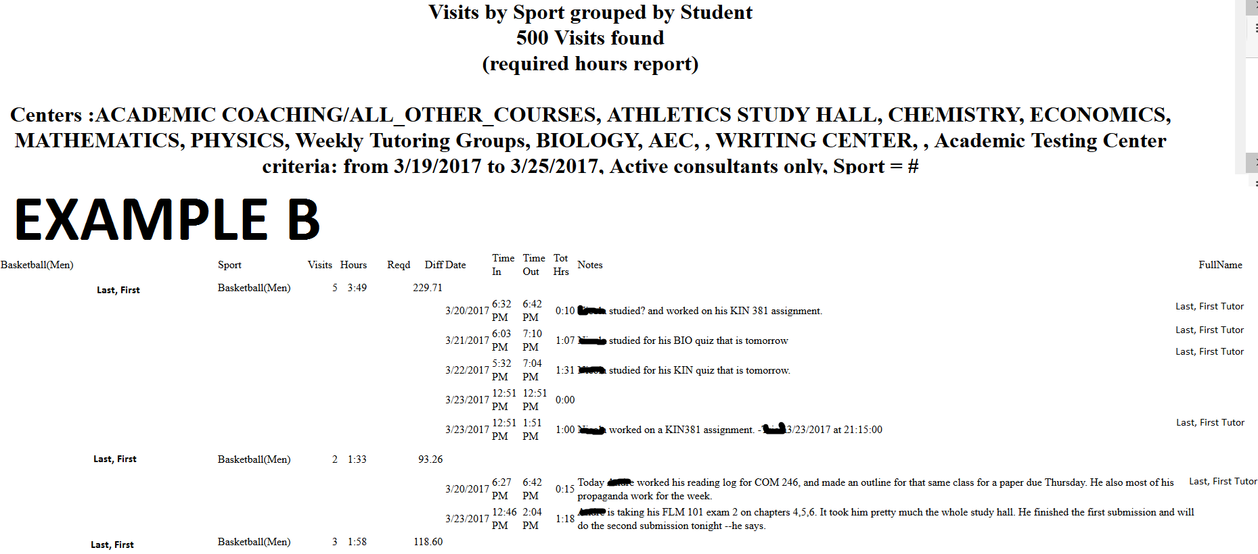

**Automated Team Specific Nightly Notes**

**Example C**

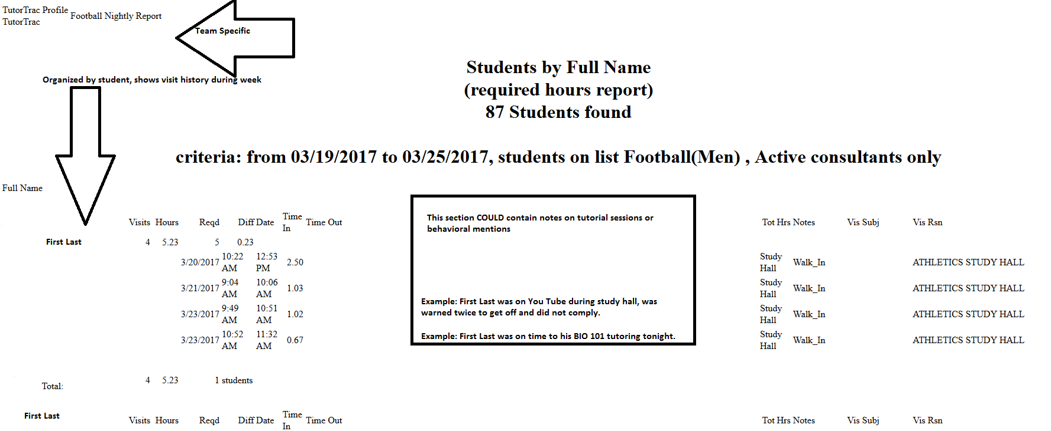

**Time Check Feature**

