Get All the Facts & Figures: Reports at Your Fingertips
Automatic Reports
Reports can be set up to run on their own and then emailed to you automatically.
1) Pick a Time
- Sign in as System Administrator
- Open Auto Events tab. Goto: Trac Navigation > TracMan icon > Utilities and Prefs... > Auto Events tab.
- Take note of times when no other Auto Event is running.
- Click the Auto Reports tab.
- Notice times of all Auto Report processes.
- Choose a unique time to run your new Auto Report – don't overlap any other Auto Event or Auto Report process.
NOTE: Double check the time you choose is not the same as any other Auto Report or Auto Event. This is extremely important. If auto processes attempt to run at the same time, one or both will not execute.

 | 2) Create New Auto Report Process
 | - Go to:  Auto Reports tab > New button  - Check-mark 'is Pending'  - Last Performed: set as the last date it would have ran – if it was already auto-running.  - Fill out the rest of the settings as desired.  - Time: must be unique when compared to all other Auto Events and Auto Reports.  - Linked Report box will be empty for now. We will link a report to this process, later.  - Save | 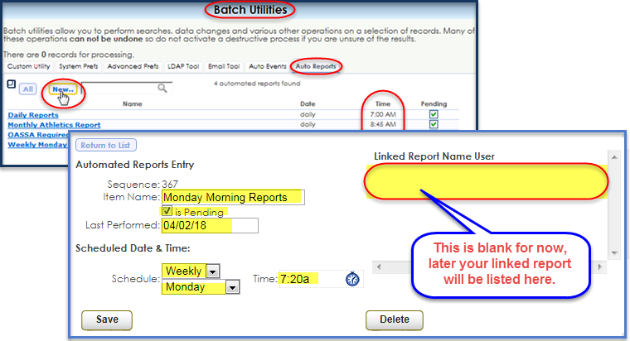

 | 3) Make a 'Favorite' Report  - Goto: Trac Navigation > Reports > (choose your report).  - Choose an automatic date range (use drop-down box, to the right of date ranges).  - Check-mark 'Auto Recompute Dates'.  - Delivery: Email  - Use semicolon to separate multiple email addresses  - Check-mark 'Save new favorite'  - Name the report.  - Click 'Generate' button. (This saves your report to the favorites category.) | 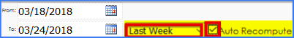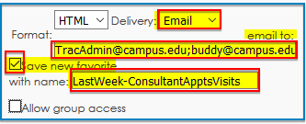
4) Link Report to Auto Report Process
- Goto the 'Favorites' category of reports in the Report Chooser.
- Click on the favorite report you just created.
- Check-mark 'Save over existing favorite' (near bottom of window).
- Click the 'Auto run...' Button (below the listing of favorite reports).
- Click the name of the Auto Report we created in step 2.
- Click 'Generate' button to save. This sends the report to the report's listed email addresses and saves the link to the Auto Report process you just selected.
- Double check the automated report. Go back to the 'Auto Reports' tab in Batch Utilities. Click the auto report process you assigned the favorite report to. You will see the 'Linked Report Name' to the right.

