Connect
Report
Success
Record
Power Search, Lists, & Watch Lists
Power Search Symbols
@ is the Wildcard
# is not equal to
> is greater than
>= is greater than or equal to
< is less than
<= is less than or equal to
... is a range of values
| Represents an “OR”

Power Search: The Power Search has different fields for students and the option to add the students on a list. To locate the option go to the Student Listing then click on List Option and select Power Search. The Power Search displays different fields and the option to add more by clicking the Add Line link. An example is having the first field selected for GPA, the greater than or equal to 3.0 GPA and the next line is for Grade, A through C have been entered. These fields are looking for all students with a GPA 3.0 or higher and grades C or better.
Standard Search:GPA >=3.0 and Grade A...C 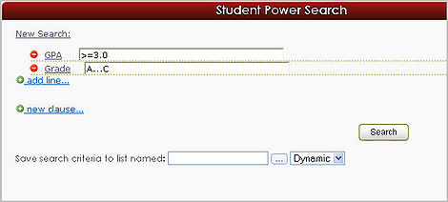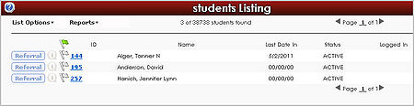
Student lists: Student Lists can be used to track student populations. These special populations can be defined via import, TutorTrac Searches or manually selected. Two types of Student lists are offered in the Trac system.
The first option is a Static list which contains a list of students and does not change unless manually modified by end users or via import. This is useful for capturing a snapshot or moment in time, for example 2017 Baseball Team or FA17 Honors.
The other option is a Dynamic list that is updated constantly, for example you might have a list called “At Risk” that is dynamically calculated from the Students GPA. As the Student’s GPA changes the student might be added or subtracted automatically.
Student lists are most commonly viewed from the Student Listing List Options Lists menu. Lists are also accessible in most reports to allow you to filter your reporting to just those students.
Watch Lists: Watch Lists go hand in hand with Student lists. A high priority student list can be assigned as a Watch List. Watch lists add a visual indication (a color selected dot) that can let staff quickly know that a student is a member of a particular Student list without the need to search or open the student account.
Watch List dots can appear on Log in, Appointment Entry, Student listing, Log listing and more. Watch Lists can be assigned from the Trac Navigation Menu - Utilities and Prefs System Prefs Watch List

Helpful Links
http://wiki.go-redrock.com/wiki/Watch_List

http://wiki.go-redrock.com/wiki/List_Management

http://wiki.go-redrock.com/wiki/Search_Options

