- Click on the Tracman

- Click on “Utilities and Prefs…”
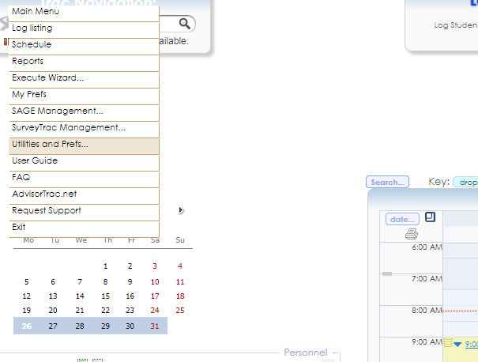

Under the “Advanced Prefs” tab:
- Use the search bar to find ”SCRIPT:SAGE-ExportOptions”

- Click on “SCRIPT:SAGE-ExportOptions”
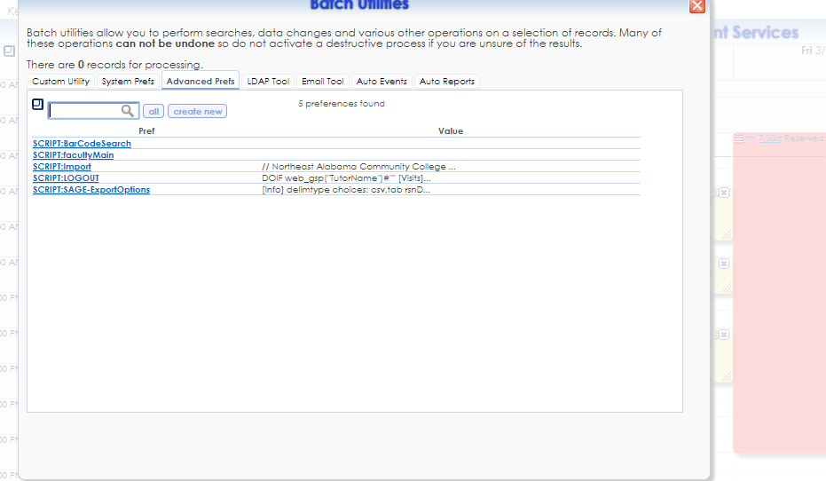

*An email signaling report completion will be sent to the addresses listed in ResultsEmailTo= ;
Multiple email addresses will be seperated by a semicolon.
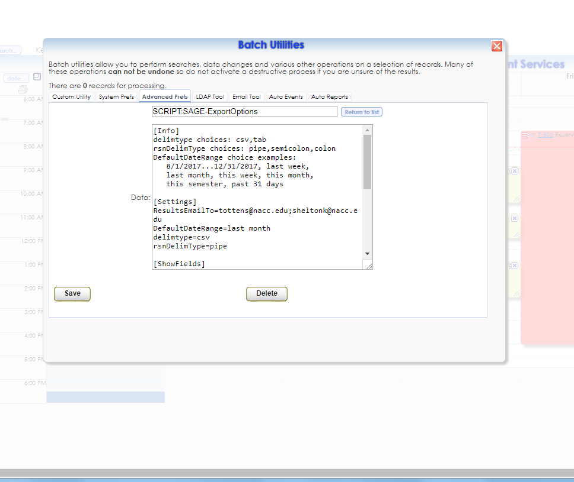
- Under “Auto Events” click on “SAGE-Extract”
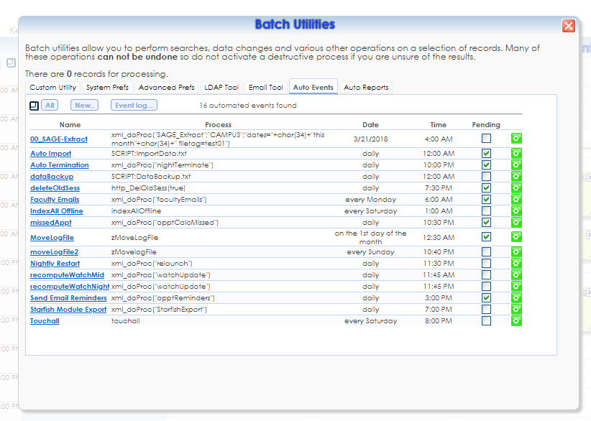
- Input the desired date for the report to run, and choose “Save”
*To be done before reporting period
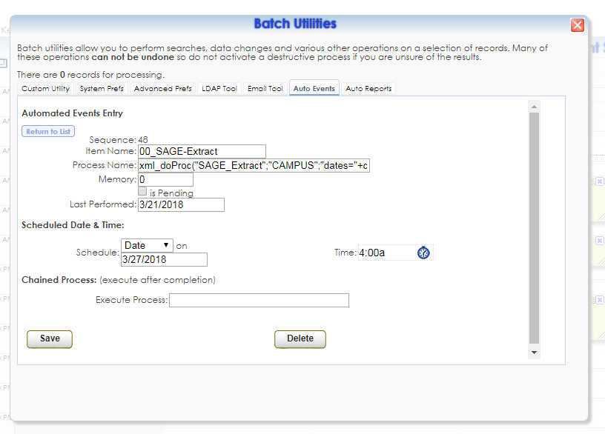
- Click on “Custom Utility” and choose “Sys Admins” as the utility category.
Select “View Sage Referral Export Status”, and click “Execute”.
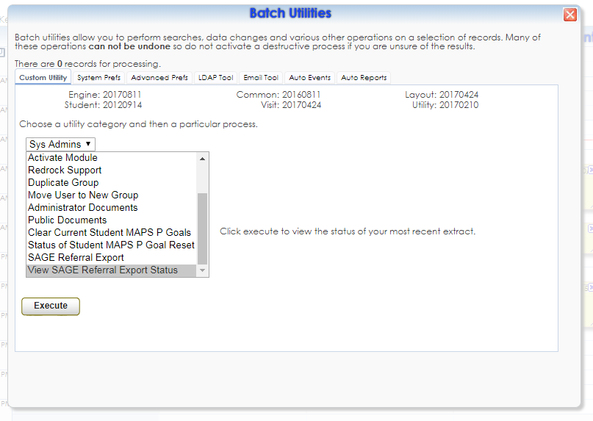
After clicking “Execute”, the report will be available in an Excel spreadsheet (ready to mail merge) on your AdvisorTrac server.

