Essentialism: The Disciplined Pursuit of Less
Learn to Discern

The vital few
- Less but better
- Essential intent
- A unified team; new level of contribution

The trivial many
- Everything to everyone
- Everything is a priority
- A millimeter’s progress in a million directions

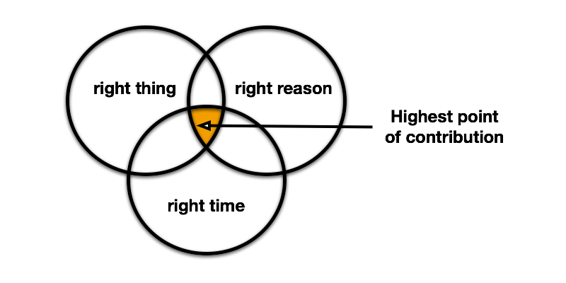
Three questions:
1. What are we deeply passionate about?
2. What taps into our collective talents?
3. What meets a significant need at Stevenson University?

Adapted from McKeown, G. (2014). Essentialism: The disciplined pursuit of less. New York, NY: Crown Publishing Group
Community Collaboration Activity
Think-Pair-Share
Step 1: Individually, brainstorm three problems that you experience in your center/office/department/etc… that you have not been able to easily solve..
Problem #3:
_____________________
Problem #1
_____________________
Problem #2:
_____________________

Step 2: Pair up with a partner, explain problem(s) and discuss possible long term solutions.

Solution(s):
- ____________________________________

- ____________________________________

- ____________________________________

Solution(s):
- ____________________________________

- ____________________________________

- ____________________________________

Solution(s):
- ____________________________________

- ____________________________________

- ____________________________________

Step 3: Share with a small group and discuss possible internal or external partnerships to implement the solution(s).
Possible Partner(s):
- ____________________________________

- ____________________________________

- ____________________________________

Possible Partner(s):
- ____________________________________

- ____________________________________

- ____________________________________

Possible Partner(s):
- ____________________________________

- ____________________________________

- ____________________________________

